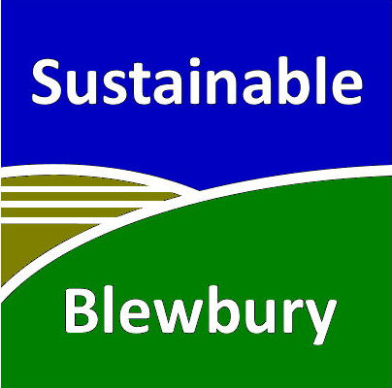 | ( Insert your address  and email address)  (Insert Date)
(Insert your MP’s name), MP,
House of Commons,
London SW1A 0AA

Dear (your MP’s name) MP
I am writing to you about my deep concern about the dramatic impact that climate change is already having on many countries throughout the world and the threat that it poses to future generations here in the UK. It is very important to me that my personal conviction towards sustainable living is reflected by the MP representing me.
I welcomed both the Conservative manifesto commitment to “being the first generation to leave the natural environment of England in a better state than we found it”, and the government’s climate pledge in February to “accelerate the transition to a competitive, energy-efficient low-carbon economy”, but decisions made by ministers since the election appear to be directly counter to both.
The UK is falling far short of reaching the target of an 80% reduction in greenhouse emissions by 2050, as set out in the 2008 Climate Change Act. I am concerned that this government will fail to catch up with the targets set out in the fourth carbon budget.
The Conservative Government must make climate change a top priority if we are to secure our energy supply, prevent severe flooding, protect areas of natural beauty and most importantly, guarantee the future of generations to come. The Conservative manifesto says it supports the Climate Change Act. Consequently, could you tell me if you will act on the recommendations of the Climate Change Committee in order to reach the agreed targets?
Additionally, the UK must play an active role in securing ambitious agreements for emission reductions and climate finance at the Paris COP21 this December. The recently published UN synthesis report¹ says that ”Fully implemented these 140 individual climate action plans together begin to make a significant dent in the growth of greenhouse gas emissions .... , but they have only the capability of restricting forecast temperature rise to 2.7°C by 2100”, not the 2.0°C which is the agreed objective of the conference.
To this end, can you please pass this letter on to Amber Rudd MP, Secretary of State for Energy and Climate Change? I would be very pleased to know of any response that you receive from her.
There are many changes that can also be made on a local level that can improve the quality of life for local residents as well as tackling global climate change: improving air quality and recycling facilities, installing solar panels on schools and social housing, creating better walking and cycle paths, and cultivating more communal green spaces. I would be glad to know if you are willing to support these initiatives in (insert Area).
I look forward to your response.
Best wishes,

(Name)

